Hitachi Impact Testing Analyzer

- Overview

Hitachi impact testing analyzer (HITA) helps determine the scope of software change impact. By viewing the displayed model, users can realize the relationship between each functions in a system.
eMonkeyTM's automation mechanism is open, agent-based, and extensible to almost any new type of device or platform. Technically, agents can be platform specific, but they all share the same communication protocol which relies on TCP/IP.
eMonkeyTM architecture consists of 3 important parts: eMonkeyTM Development Center (DC), eMonkeyTM Test Factory (TF) and eMonkeyTM Agent.
- eMonkeyTM DC – develop automated test quickly and efficiently with many advanced features such as keyword driven, IP-based environment, team version control… Scripting can be performed via its editor or test developers can directly record actions on test target device then convert them into script.
- eMonkeyTM TF – manage all aspects of automated Test Runs, including test cases and test scenarios. This facilitates the creating test plan phase. Besides, eMonkeyTM TF also provides Test Reports management that helps the test managers monitor reports of all tested applications.
- eMonkeyTM Agent – is deployed on specific device or platform to interact with Application Under Test (AUT). Agents act as communication bridge between eMonkeyTM DC/TF and target AUTs.

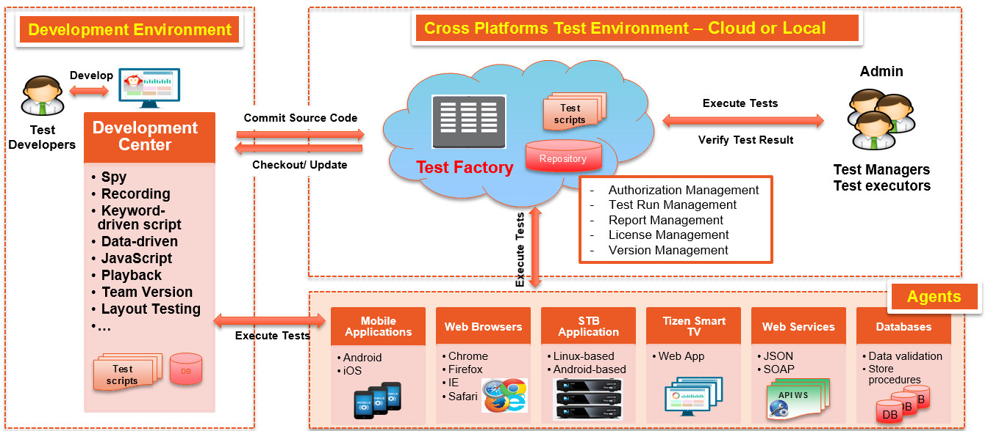

eMonkeyTM - System Overview

eMonkeyTM ADVANCED FEATURES
- IP-based test environment: Test scripts/scenarios can be executed simultaneously on many devices by using WIFI network.
- Single test script on multiple platforms: eMonkeyTM offers reusable test scripts to test on multiple devices, reduces time and resource for developing these test scripts.
- Keyword-driven testing requires minimal scripting language skill: Keyword-driven and Data-driven testing fully eliminate the difficulties in developing test scripts, long-term test, and maintenance, optimize time and resource for executing test scripts. The users can immediately start to create test scripts based on a ready-to-use Keyword library in the most intuitive and simplest way.
- Integration ability: Apply eMonkeyTM to run sanity test before releasing to QA team. Bugs are reported to bug tracking system and test results are posted to test management system in an automatic and timely manner.
- Team version control: Support managing (e.g. Checkout, Update, Commit, Resolve conflicts) and sharing the versions of test scripts directly and effectively among team members.

- Main and VALUE-Added FEATURES
2.1. eMonkeyTM Development Center (DC)
- Record
- Record user’s actions on a particular browser/device
- Capture all interactions on application user interface
- Convert user’s actions into step-by-step scripts
- Insert keywords during the recording
- Edit test scripts during the recording

- Spy
- Build Application Repository
- Recognize the application UI objects
- Update the object properties
- Store the objects into repository
- Utilize the objects to develop test scripts

- Playback
- Run test scripts
- Edit test scripts per testing purpose
- Run test scripts on multiple web browsers/devices/platforms
- Use TCP/IP connection for simultaneous tests

- Keyword/Data-driven
- Use keyword in English requiring minimal scripting language skill
- Support test script creation in JavaScript
- Support data in CSV, Excel, XML, and DB

- Object Repository
- Recognize objects and their attributes during the recording
- Insert/update the object data
- Manage the object repository

- Validation
- Validate the syntax during the test script creation
- Support various checkpoints
- Pinpoint failed steps with a full log
- Capture screenshots of the failed steps

- Test Management
- Create and manage the test scripts/test scenarios
- Execute simultaneous tests across multiple browsers/devices
- Schedule and repeat the tests for desired times (iteration)

- Team Version Control
- Manage the versions of test scripts/test scenarios/repositories etc.
- Support updating the versions of test scripts on Test Factory
- Allow multiple test executors running test scripts in parallel

- Supported Applications and Platforms
- Web and desktop applications: Windows, Linux, Mac OS
- Mobile applications: Android, iOS
- Set-top-box: Linux-based, Android-based
- Smart TV: Samsung using Tizen OS

- API Web Services
  - Support specifying test data via pre-defined payloads
  - Allow defining simple and highly customizable testing conditions
  - Allow validating multiple API WSs concurrently and automatically
  - Support evaluating and running both functional and non-functional tests
  - Support user-friendly GUI or advanced manual scripting GUI
  - Identify errors more quickly and accurately using visual and real-time test results

2.2. eMonkeyTM Test Factory (TF)

- Access Control Management
  - Create an account and assign roles to each user within a company
  - Authorize access and action per project from different companies

- Test Runs Management
  - Create test runs for multiple devices
  - Execute regression test of pre-scheduled tests automatically
  - Manage the project status and its progress
  - Notify errors arising while testing
  - Manage versions of test scripts

- Devices Management
  - Monitor the device operations and detailed information

- License Management
  - Support managing the license using credit (*), prepaid for the number line-of-codes
  - Allow companies to manage the license permission per account.
(*) Credit is the total points prepaid to the client’s account.
- Reporting
  - Support various Test Reports (i.e. summary, details, comparisons)
  - Save reports in HTML and PDF formats
  - Manage the Test Report per individual project

- Integration ability
  - Allow applying eMonkeyTM to run sanity test before releasing to QA team
  - Support integrating with external bug tracking and test management system, such as Jira and TestLink.

- BENEFITS

- For QC/QA Staff
  - Support developing test scripts on specific platforms
  - Support identifying and storing objects on a specific platform (browser/device), then modify these objects to match each testing environment
  - Allow executing the tests across various devices on different platforms
  - Enable test developers to simulate a large number of users
  - Enable test developers to plan and execute test cases with pre-defined iterations
  - Allow running APIs Web Services tests quickly, helping the user to identify security vulnerabilities in the public interfaces
  - Support monitoring/managing different versions of test scripts seamlessly and effectively

- For Manager
  - Support planning and analyzing the tests fully and proactively
  - Enable test managers to monitor and manage testing process and quality better and more closely

- System Deployment Model

eMonkeyTM can be deployed by using the following models:

- Prepaid model: User will install eMonkeyTM Development Center (DC) at no cost and pay credits for the number line-of-codes used in eMonkeyTM Test Factory (TF) controlled by Global CyberSoft.
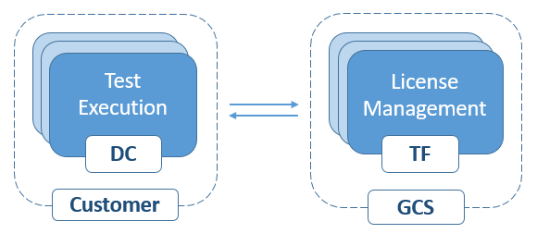

Full package model: Provide a full package including eMonkeyTM Development Center (DC) and eMonkeyTM Test Factory (TF) with unlimited number line-of-codes.
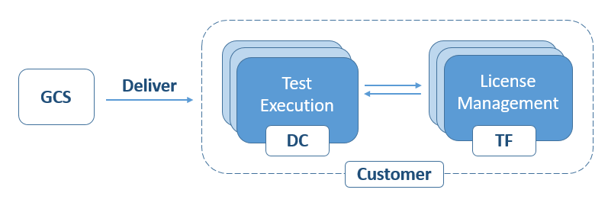



About GLOBAL CYBERSOFT (VIETNAM) JSC (GCS)
Global CyberSoft is a leading global IT solutions provider founded in California in July 2000 and has been a company of Hitachi Consulting Corporation since October 2014. We have many years of expertise in providing premier IT solutions and systems integration services to customers in more than 18 countries around the world in the business areas: Factory Automation, ERP/HCM & BI, Business Automation/Supply Chain Management, Embedded Systems and Testing Services.
Please visit our website for more details.
Global CyberSoft (Vietnam) JSC
Helios Bldg., Quang Trung Software City
Tan Chanh Hiep Ward, District 12
Ho Chi Minh City, Vietnam
Email: salesvn@gcs-vn.com
Tel: +84 28 5437 1199 Fax: +84 28 5437 1188

